**Experiment No. 2.3**

**Student Name:** Gaurav Kumar **UID:** 22MCC20177

**Branch:** MCA**–**CCD **Section/Group:** MCD-1/A

**Semester:** III **Date of Performance:** 25th Oct 23

**Subject Name:** CONTAINERIZATION **Subject Code:** 22CAH-742

WITH DOCKER

1. **Aim/Overview of the practical:**
   1. Maintaining States with Docker Volumes.
2. **Code for practical: (a)**
3. First create a volume and inspect.

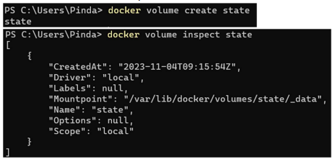

1. Create a container using image with some additional flags:

-v for volume

-it for interaction mode

--name container name



1. Container is in running state.
   * Specify the path.
   * Create some files or data in the running container, then exit and remove the container.

1. After removing the previous container, Now Create another container same with -v -it or –name flag.
   * Specify the path.
   * List the files.

1. Previous generated file is visible that means different containers are using the same volume.